## MetaMask

Step 1: Creating MetaMask Password:

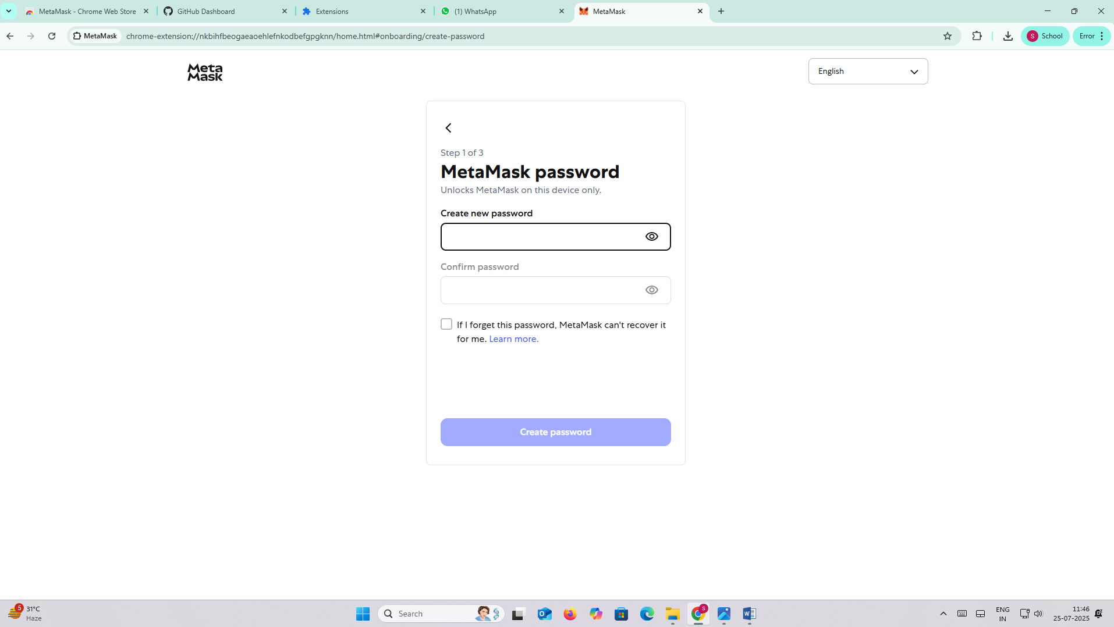

Step 2: Securing the Wallet

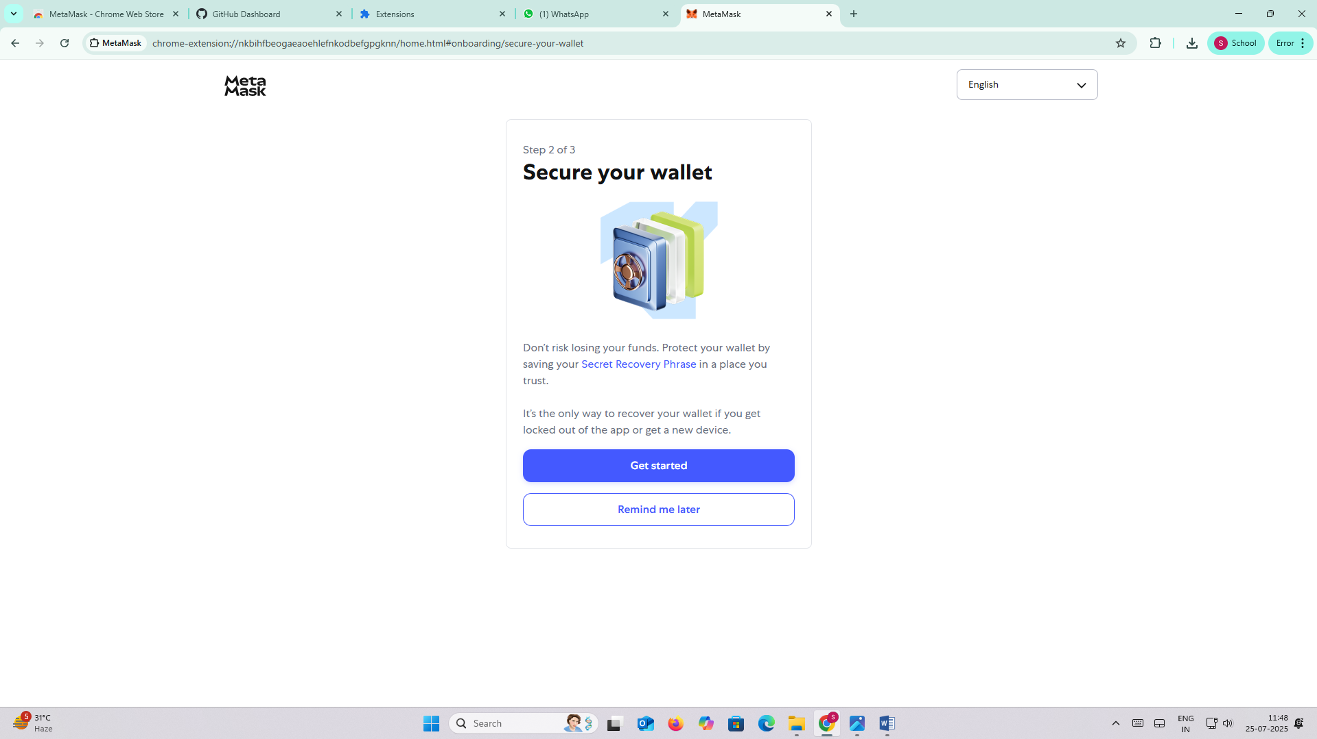

Step 3: Viewing the Secret Recovery Phrase

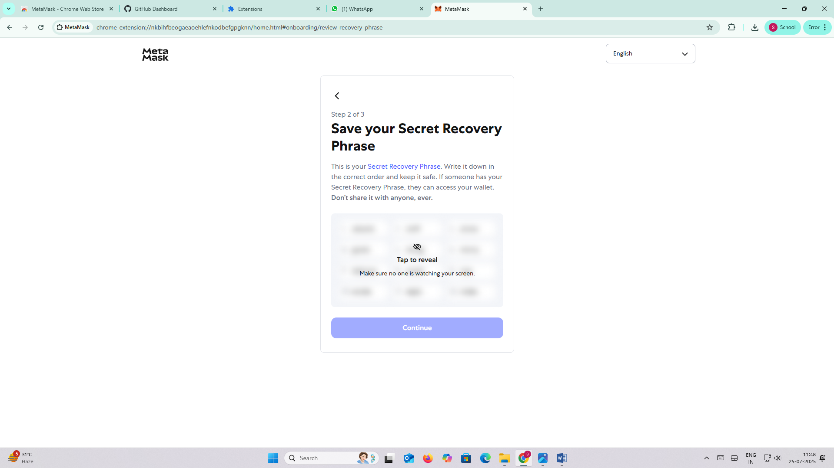

Step 4: Full Secret Phrase Displayed

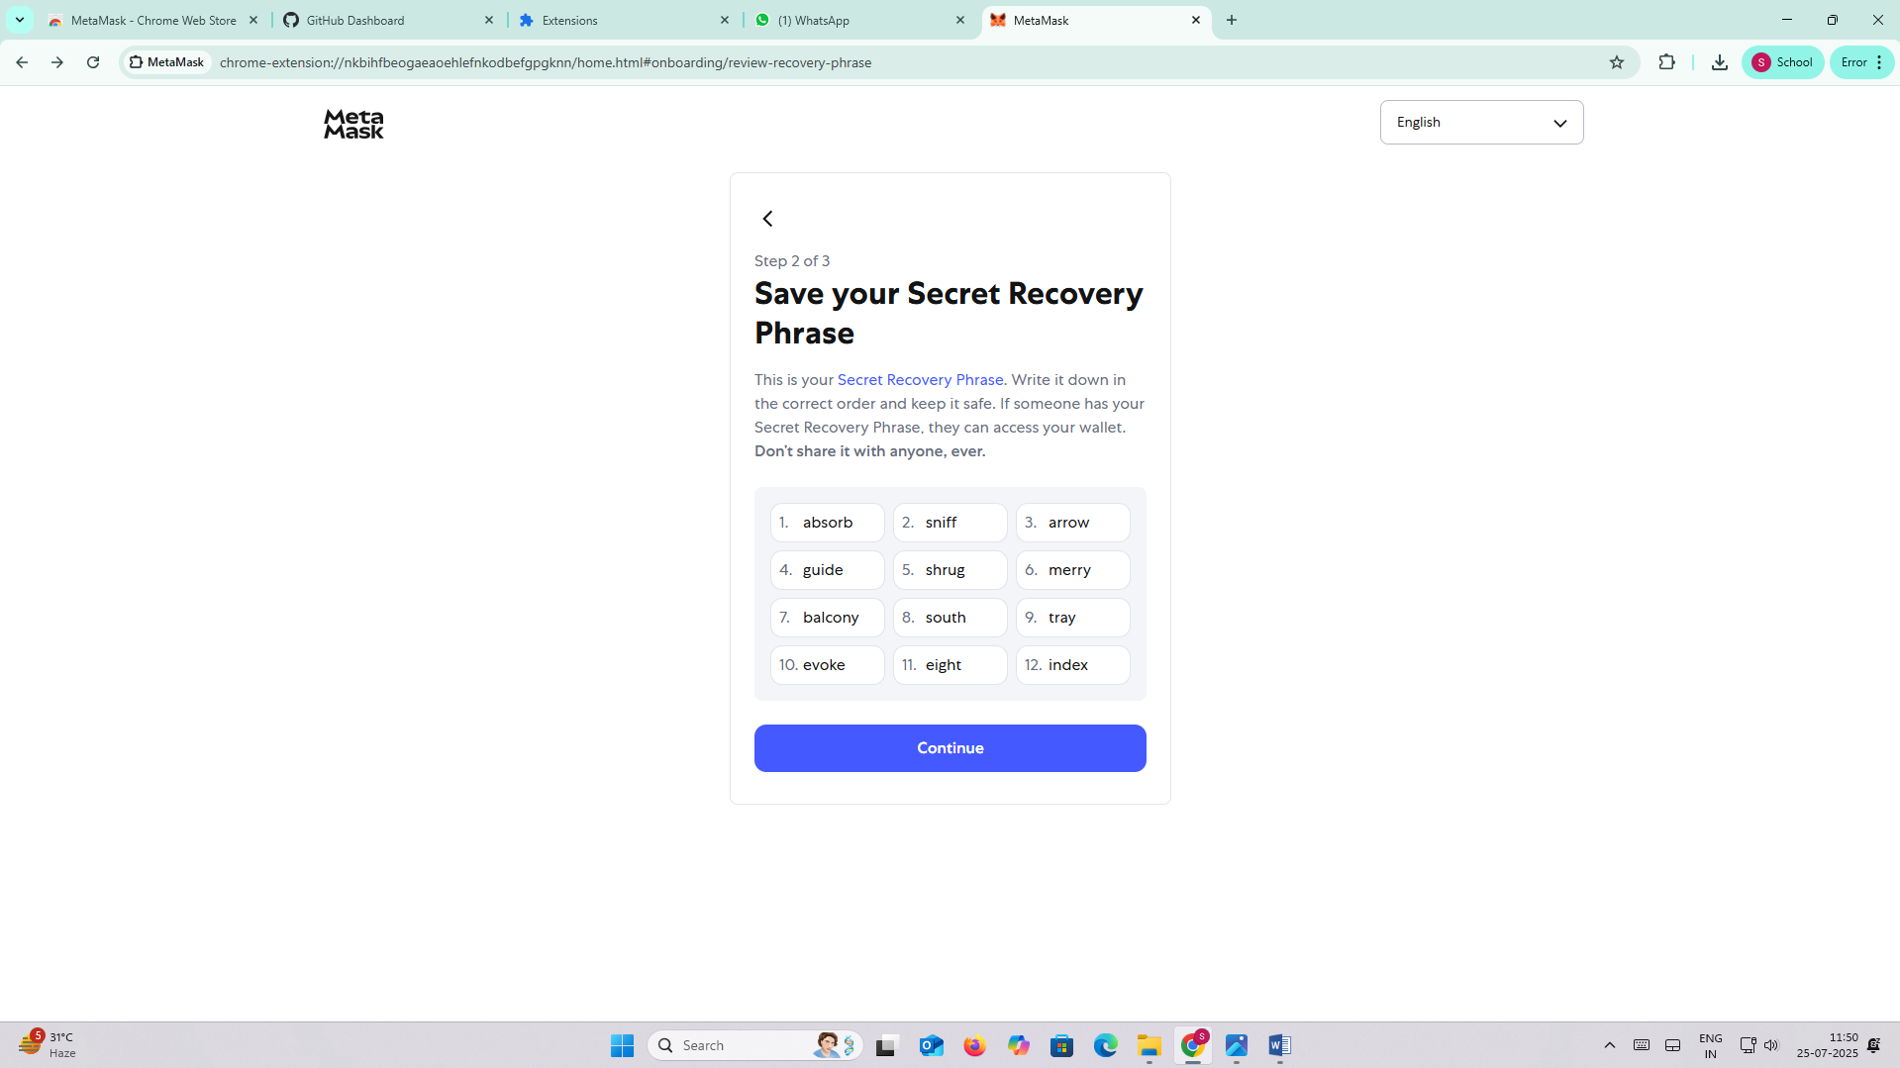

Step 5: Confirming Secret Phrase

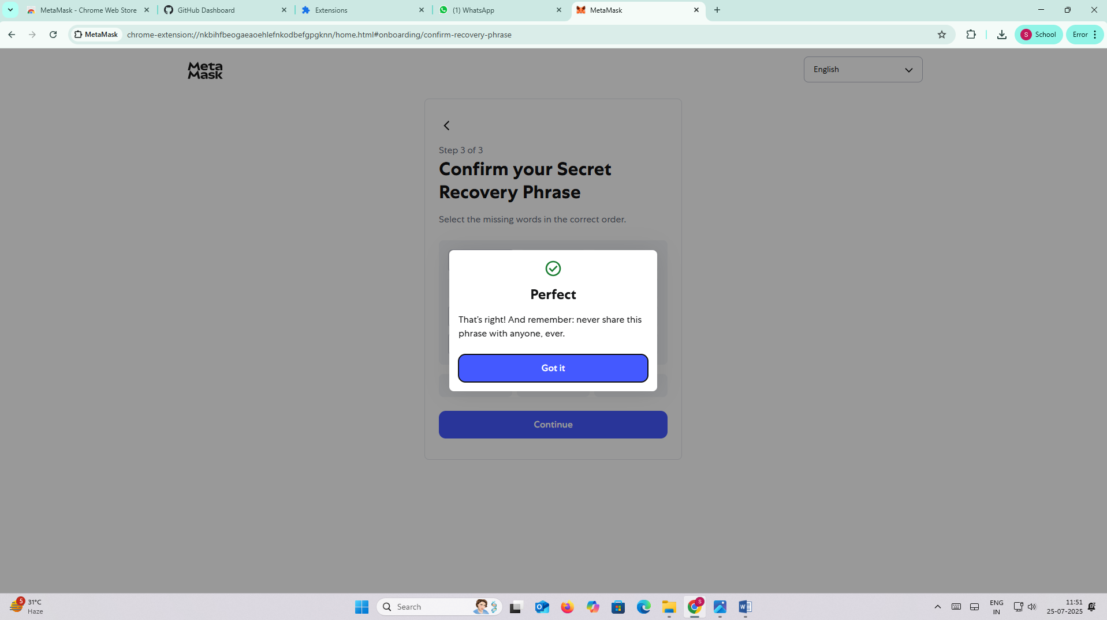

Step 6: MetaMask Confirmation

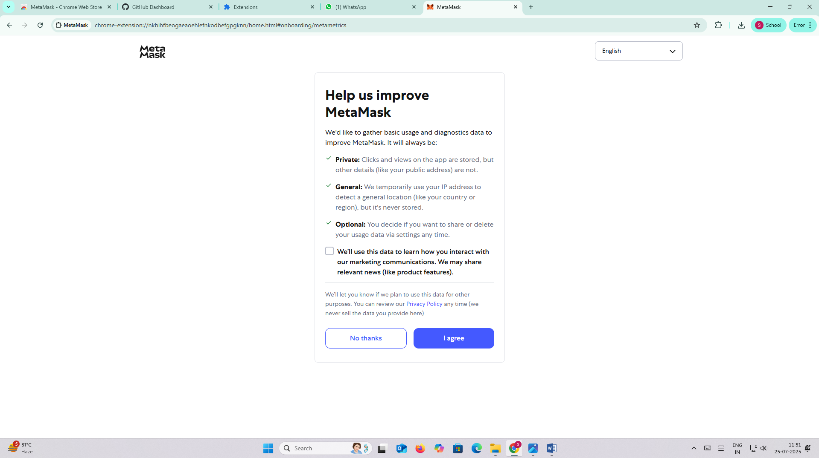

Step 7: MetaMask Optional Preferences

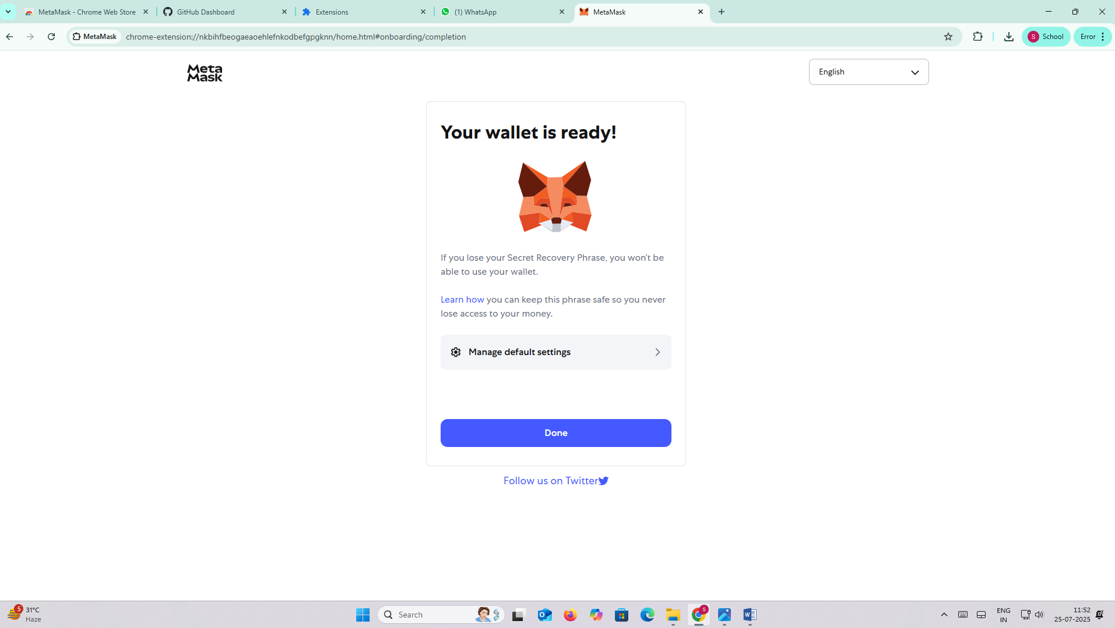

Step 8: Wallet Ready Screen

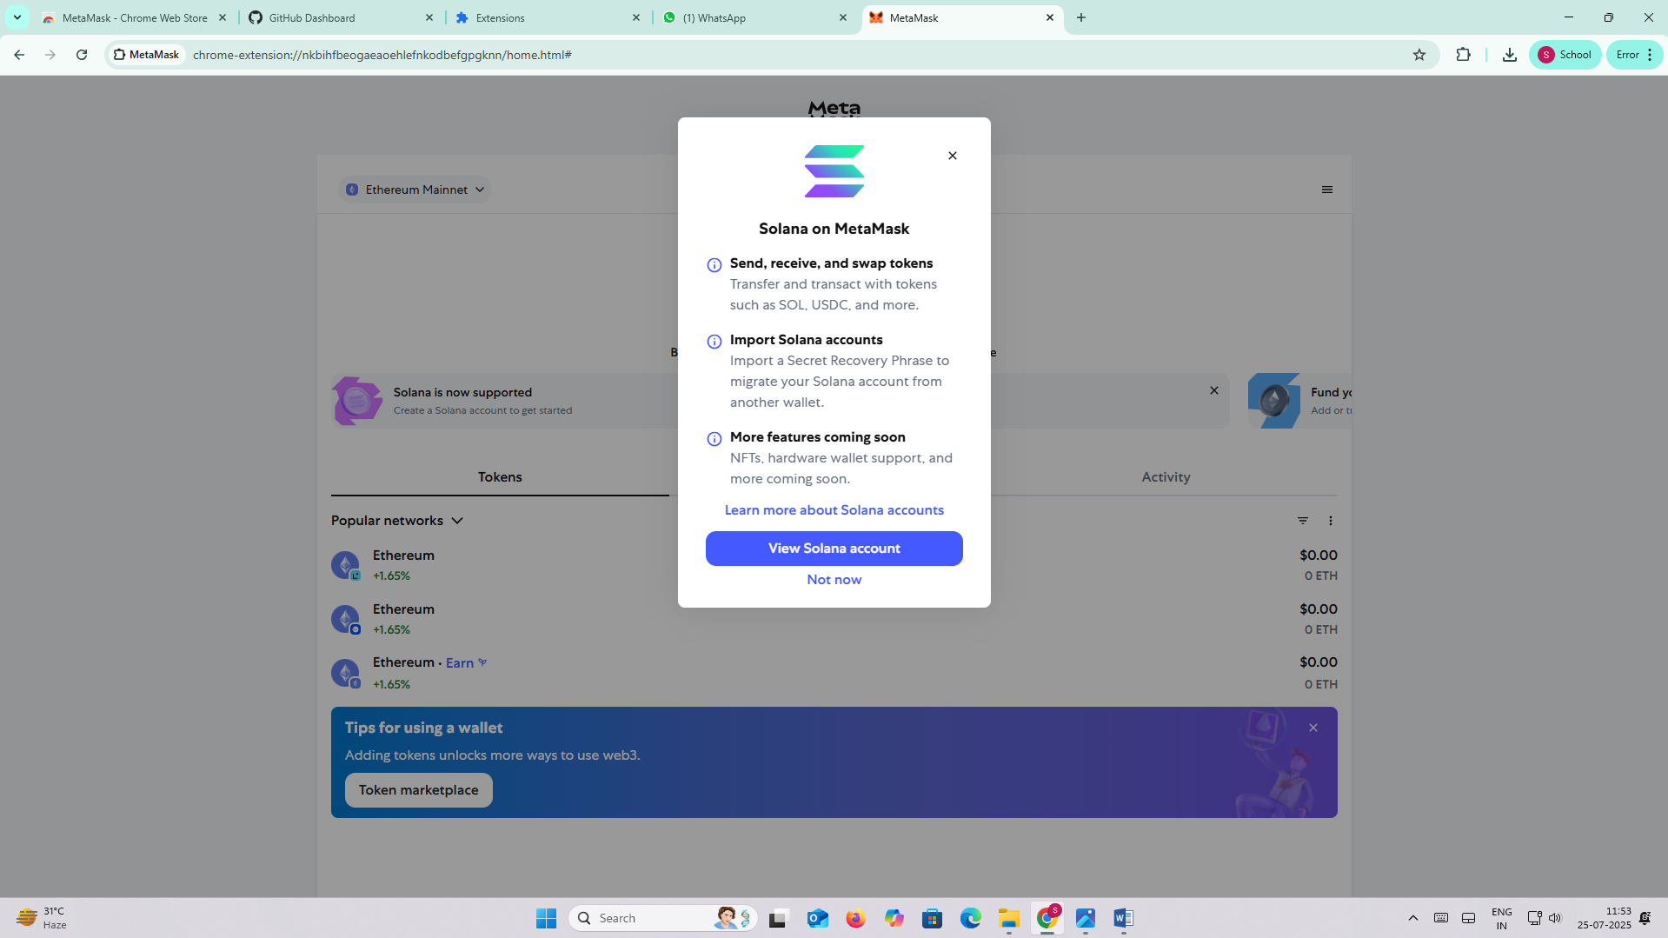

Step 9: MetaMask Dashboard

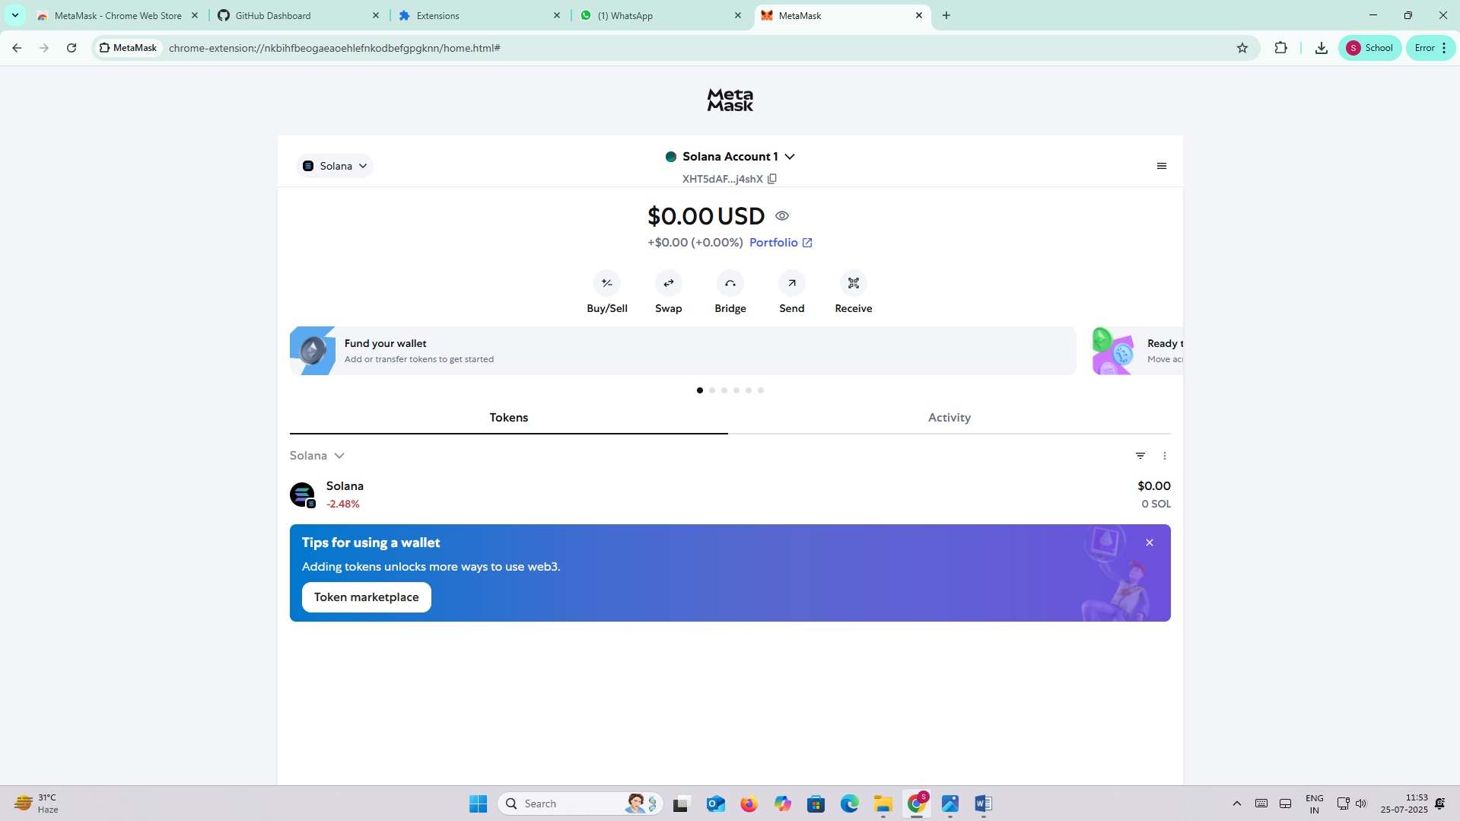

AToTmbSQWVJpUoAKLSHyjsmFYyzYiau5w4qeougYhfsy